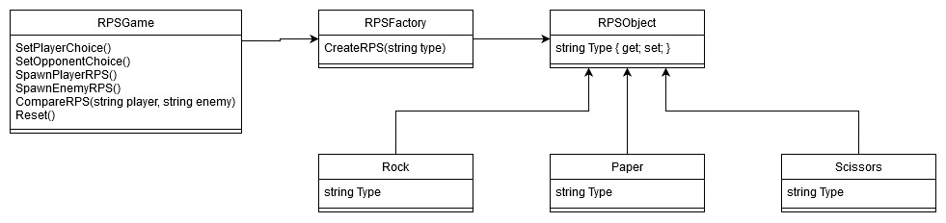CIS 452 01 – Assignment 3 Reflection

Jake Buri

1. What does the player do in the game that determines which Concrete Command is executed on a receiver?
2. What determines which Receiver class receives the command? Does the player choose the Receiver somehow or does the game choose the Receiver? In other words, what sets the Receiver that the Command is executed on?
3. What were the benefits of using the Command Pattern to make your mini-game?
4. Did you find any drawbacks to using the Command Pattern? If so, what were they?
5. What is the player’s goal in your mini-game and what makes it challenging?
6. How does the game communicate its goal(s) to the player?
7. How can the player fail at the game and how does the game detect it?
8. How does the game give players feedback about how well they are doing?

